2.Open your Command Prompt program – Terminal or Git Bash. cd to your Desktop, as you saw in the chapter. Then type ls.

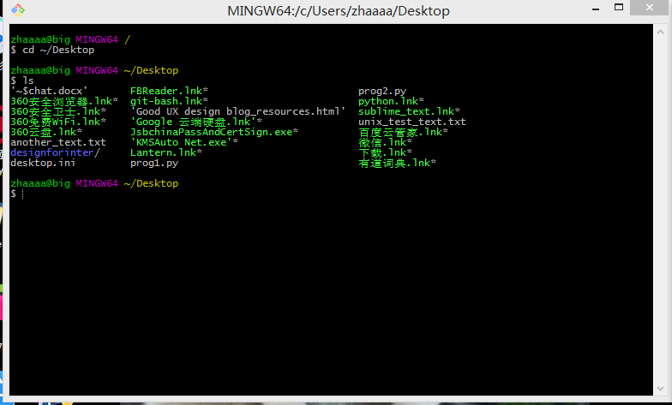

3.You now want to make a new directory called new_class_programs in your Desktop, and copy prog1.py and prog2.py into it.

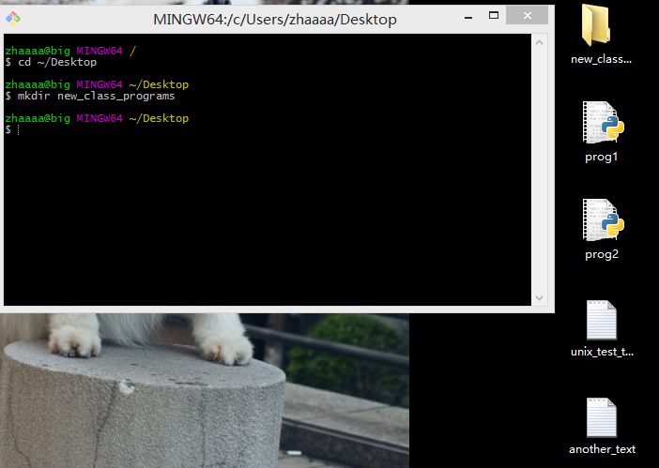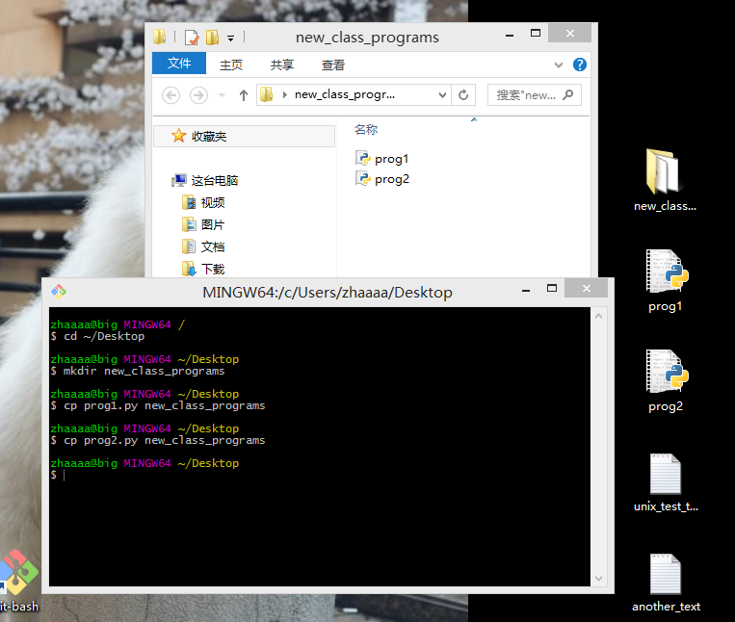

4.Now, you want to create a new directory inside the new_class_programs directory, called text_files, and copy both unix_test_text.txt and another_text.txt into that folder.

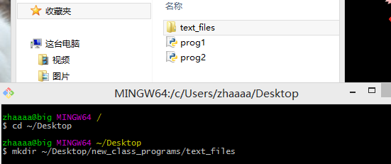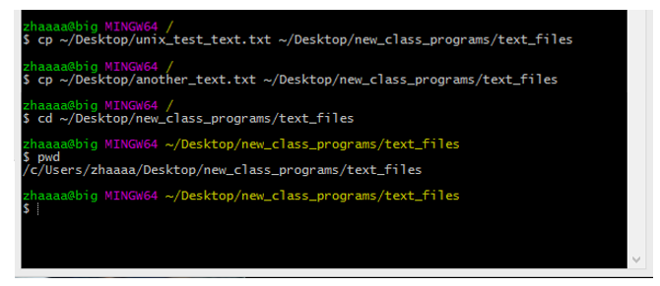

5. Use a unix command to view the content of prog2.py before you open it

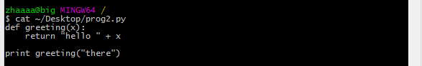

6. You want to concatenate the 2 text files inside the text_files folder together, and save the result in a file called big_story.txt

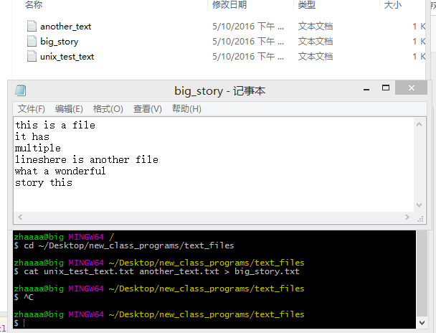

7. You now want to see a list of all the files and/or directories inside your new_class_programs folder whose names include text

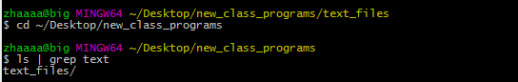

8. Go there in your command prompt, and run prog2.py by typing python prog2.py at the prompt

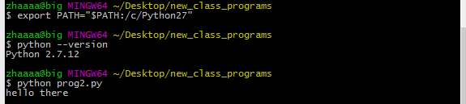

About the hangman program execution screenshot:

